Speakers Bureau
Please contact us at sssm.contact@gmail for pricing
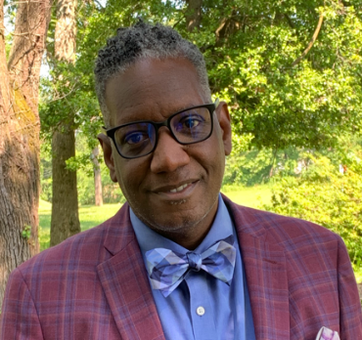 | Troy Boddy  ♦ Diversity  ♦ Equity  ♦ Inclusion
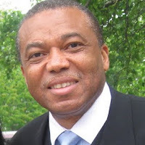 | Albert Gyan  ♦ Africans in America  ▪creating a space for dialogue and reconciliation
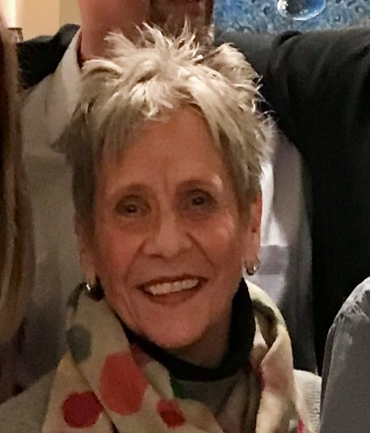 | Lydia Rappolt  ♦ Quakers  ▪history in Sandy Spring
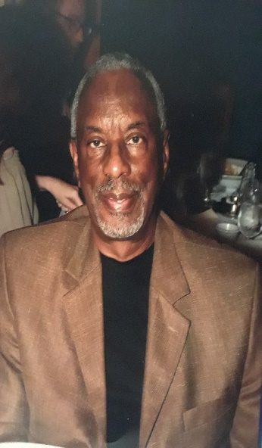 | Reynauld Smith  ♦ Civil Rights
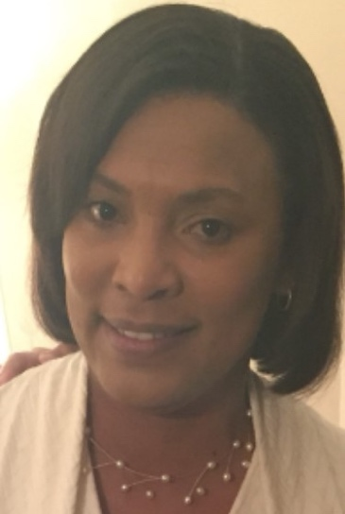 | Sandi Williams  ♦ Segregated Schools in Montgomery County, MD  ♦ African-American history in Sandy Spring, MD
Natalie Thomas
♦ African-American Genealogy
♦ Underground Railroad
♦ Slavery

“Thank You” to the following organizations for entrusting the Museum to provide your training. . .

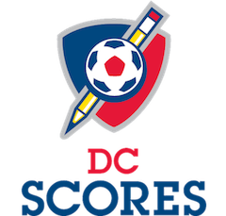 DC Scores, Washington, DC

MIO Partners, New York

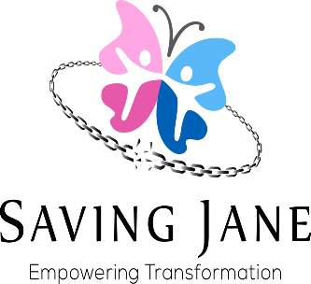 Saving Jane, Inc., New York

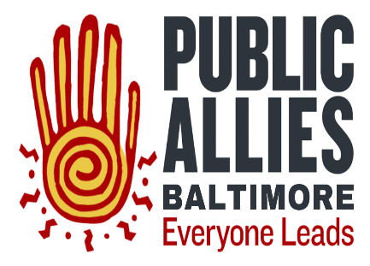Public Allies of Baltimore, Maryland

